Analysis Models

## 1. System Sequence Diagrams

**Figure 1.1 - SSD Authentication**

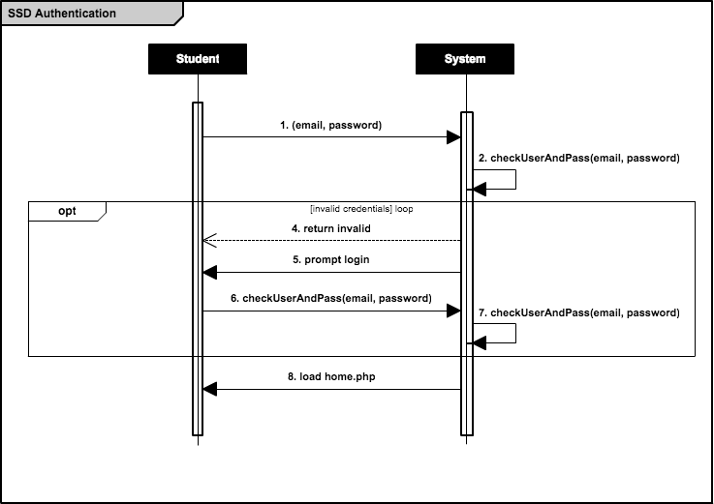

**Figure 1.2.1 - SSD Create Reservation (Booking available)**

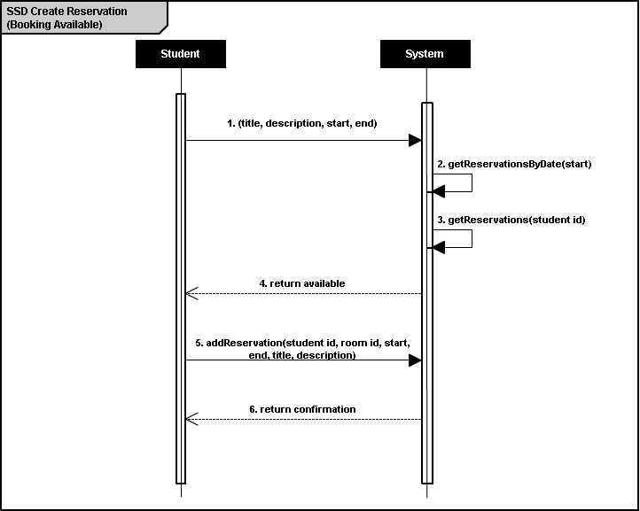

**Figure 1.2.2 - SSD Create Reservation (Booking unavailable)**

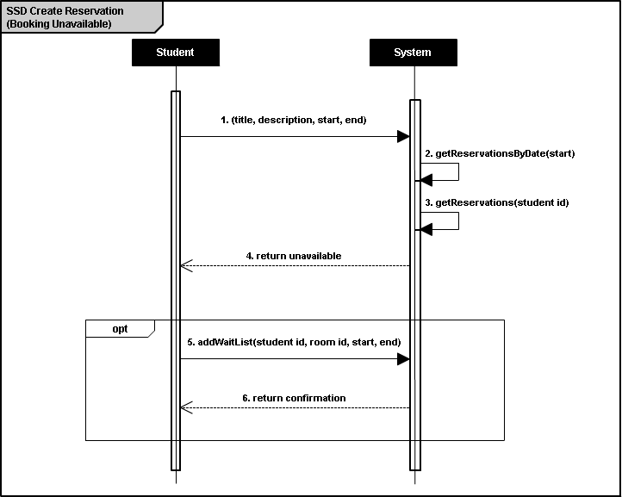

**Figure 1.3 - SSD Cancel Reservation**

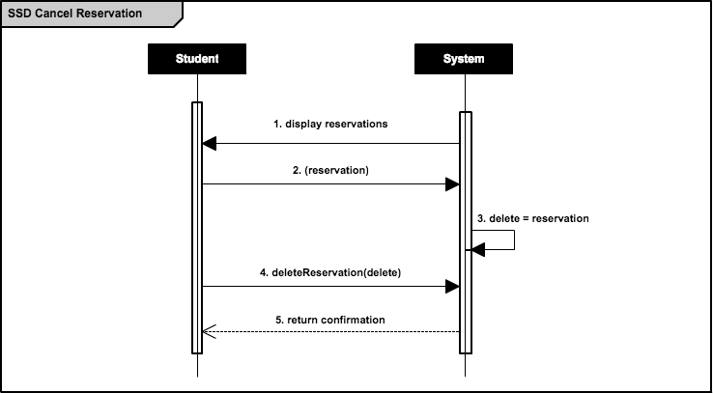

**TEMPORARY Figure 1.4.1 - SSD Modify Reservation (Time)**

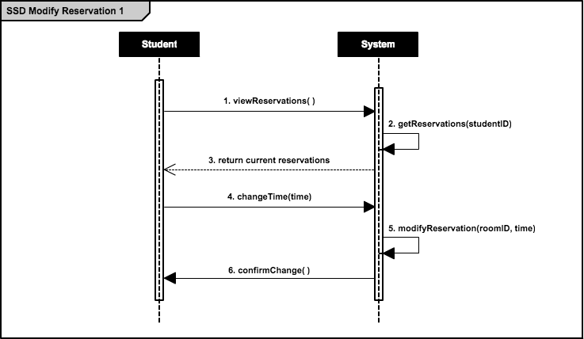

**TEMPORARY Figure 1.4.2 - SSD Modify Reservation (Room)**

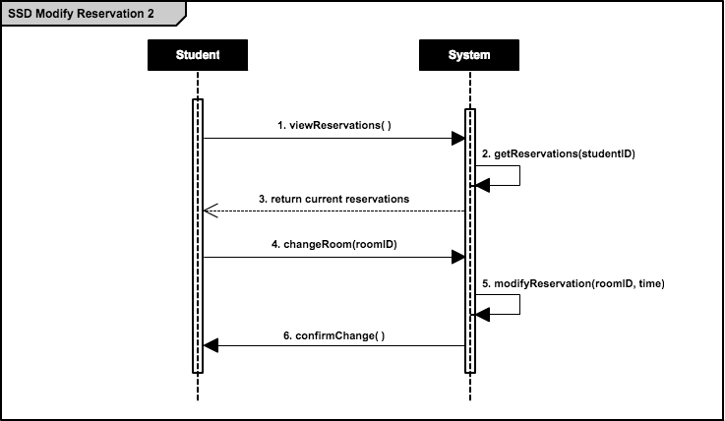

**Figure 1.5 - SSD Change Profile Details**

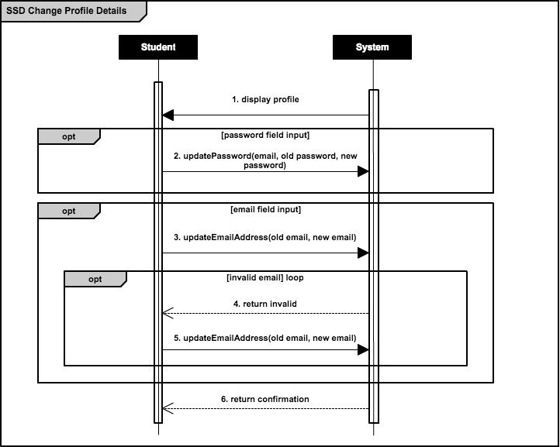

## 2. Operation Contracts

**Figure 2.1 - OC Check Username and Password**

|  |  |
| --- | --- |
| ***Operation Contract 1*** | **Check Username and Password** |
| *Contract* | checkUsernameAndPassword |
| *Operation* | checkUserAndPass(email, password) |
| *Cross-Reference* | Check Username and Password Use Case |
| *Pre-Conditions* | * User has successfully connected to authentication server * User has existing account with valid credentials * User has entered said credentials |
| *Post-Conditions* | * Instance of StudentMapper has been created * Instance of ReservationMapper has been created * Account information has been associated with session |

**Figure 2.2 - OC Add Reservation**

|  |  |
| --- | --- |
| ***Operation Contract 2*** | **Add Reservation** |
| *Contract* | addReservation |
| *Operation* | addReservation(student id, reservation id, start, end, title, description) |
| *Cross-Reference* | Add Reservation Use Case |
| *Pre-Conditions* | * User account has been authenticated (see *Figure 2.1*) * User has selected a valid room, start time, end time, date combination * User has entered a valid title and description * User has less than 3 existing reservations in that week |
| *Post-Conditions* | * Reservation has been associated with database * Student has been associated with reservation |

**Figure 2.3 - OC Add to Waiting List**

|  |  |
| --- | --- |
| ***Operation Contract 3*** | **Add to Waiting List** |
| *Contract* | addToWaitingList |
| *Operation* | addWaitList(student id, reservation id, start, end) |
| *Cross-Reference* | Add Reservation Use Case |
| *Pre-Conditions* | * User account has been authenticated (see *Figure 2.1*) * User has selected an invalid room, start time, end time, date combination * User has less than 3 existing reservations in that week |
| *Post-Conditions* | * *reservation.isCreated* has been set to *true* * *reservation* has been associated with *student* |

**Figure 2.4 - OC Update Password**

|  |  |
| --- | --- |
| ***Operation Contract 4*** | **Update Password** |
| *Contract* | updatePassword |
| *Operation* | updatePassword(email, old password, new password) |
| *Cross-Reference* | Update Password Use Case |
| *Pre-Conditions* | * User account has been authenticated (see *Figure 2.1*) * User has entered a valid old password * User has entered a valid new password |
| *Post-Conditions* | * New password is associated with student |

**Figure 2.5 - OC Update Email Address**

|  |  |
| --- | --- |
| ***Operation Contract 5*** | **Update Email Address** |
| *Contract* | updateEmailAddress |
| *Operation* | updateEmailAddress(old email, new email) |
| *Cross-Reference* | Update Email Address Use Case |
| *Pre-Conditions* | * User account has been authenticated (see *Figure 2.1*) * User has entered a valid new email address |
| *Post-Conditions* | * New email address is associated with student |

## 3. Domain Model

**Figure 3 - Domain Model**

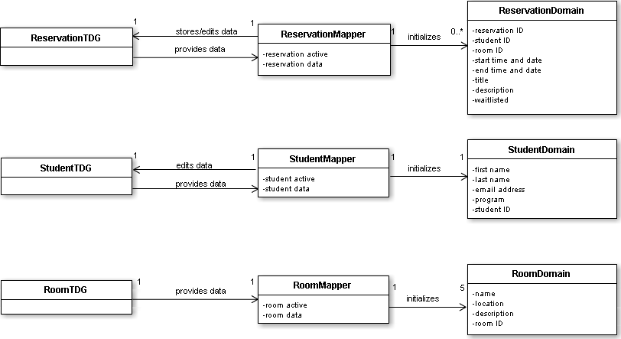

## 4. Use Cases

**Figure 4.1** **- System Use Case**

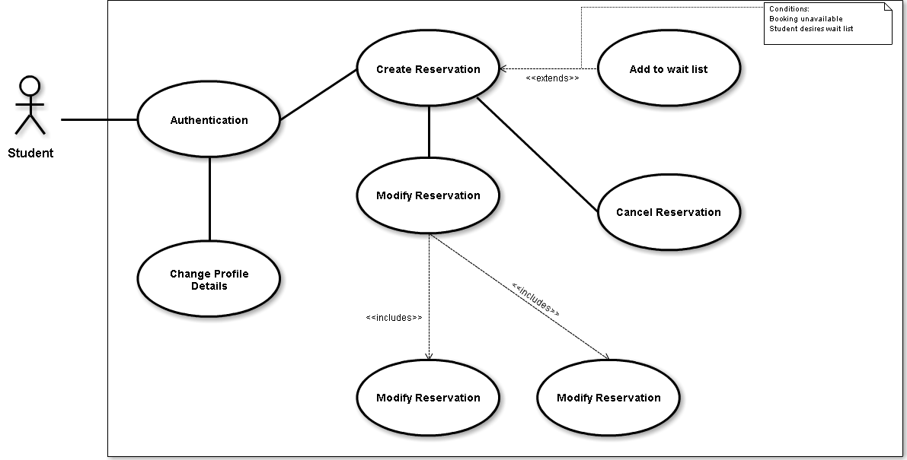

**Figure 4.2 - Check Username and Password Use Case**

|  |  |
| --- | --- |
| ***UC1*** | **Check Username and Password** |
| *Actor* | Student |
| *Goal* | Verify validity of email and password combination |
| *Summary* | Student must enter their valid credentials before being authenticated into the system |
| *Preconditions* | * Student accesses index site |
| *Steps* | * Student enters email address * Student enters password * System verifies credentials in database * System loads home page |
| *Postconditions* | * Student has been authenticated into home page |
| *Extensions* | Student enters invalid credentials, and is prompted to try again |

**Figure 4.3 - Add Reservation Use Case**

|  |  |
| --- | --- |
| ***UC2*** | **Add Reservation** |
| *Actor* | Student |
| *Goal* | Add reservation associated with authenticated student |
| *Summary* | Student selects reservation information and creates a room reservation under their name |
| *Preconditions* | * Student has been authenticated |
| *Steps* | * Student selects “Make a Reservation” * System displays reservation form * Student enters a title and description * Student selects a room and time * Student submits form * System verifies if title and description are valid * System verifies if room and time are available * System verifies if student already has 3 reservations booked in that week * System associated reservation with student * System displays confirmation |
| *Postconditions* | * Student account now associated with reservation |
| *Extensions* | If room and time combination are already booked, add reservation to waiting list |

**Figure 4.4 - Update Password Use Case**

|  |  |
| --- | --- |
| ***UC3*** | **Update Password** |
| *Actor* | Student |
| *Goal* | Change current password for authentication |
| *Summary* | Student accesses their profile and enters current and desired password for change |
| *Preconditions* | * Student has been authenticated |
| *Steps* | * Student selects “My Profile” * System displays profile information * Student enters current password * Student enters desired password * Student submits form * System verifies if old and new passwords are valid * System changes student password * System displays confirmation |
| *Postconditions* | * Student password changed |

**Figure 4.5 - Update Email Address Use Case**

|  |  |
| --- | --- |
| ***UC3*** | **Update Email Address** |
| *Actor* | Student |
| *Goal* | Change current email for authentication |
| *Summary* | Student accesses their profile and enters desired email address for change |
| *Preconditions* | * Student has been authenticated |
| *Steps* | * Student selects “My Profile” * System displays profile information * Student enters desired email address * Student submits form * System verifies if new email address is valid * System changes student email address * System displays confirmation |
| *Postconditions* | * Student email address changed |